KELCO INDUSTRIES
Paapri Cloud Technology
CASE TO RESOLUTION
PROCESS FLOW

Login To Role: Administrator
STEP 1: ASSIGN CASES OR TERRITORIES TO THE EMPLOYEE
- Check the Support Rep box in Employee Record.

NAVIGATION: Lists -> Employees -> Employees
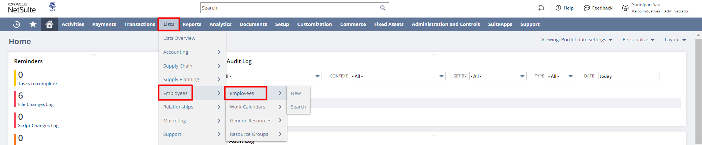
- Edit the Employee record
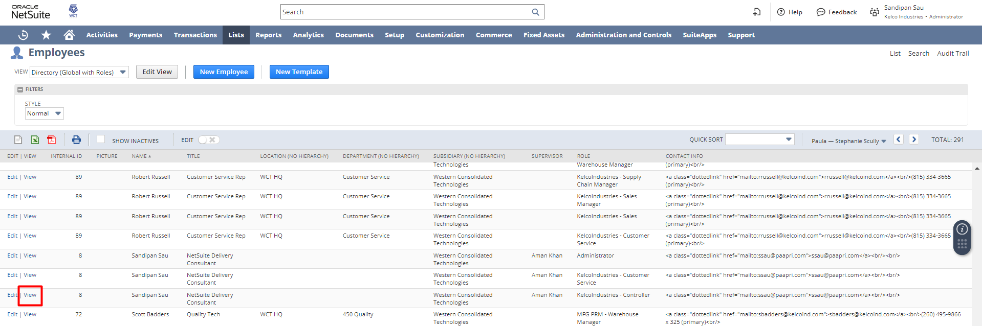
- Under Primary Information a check box “Support Rep” is present.
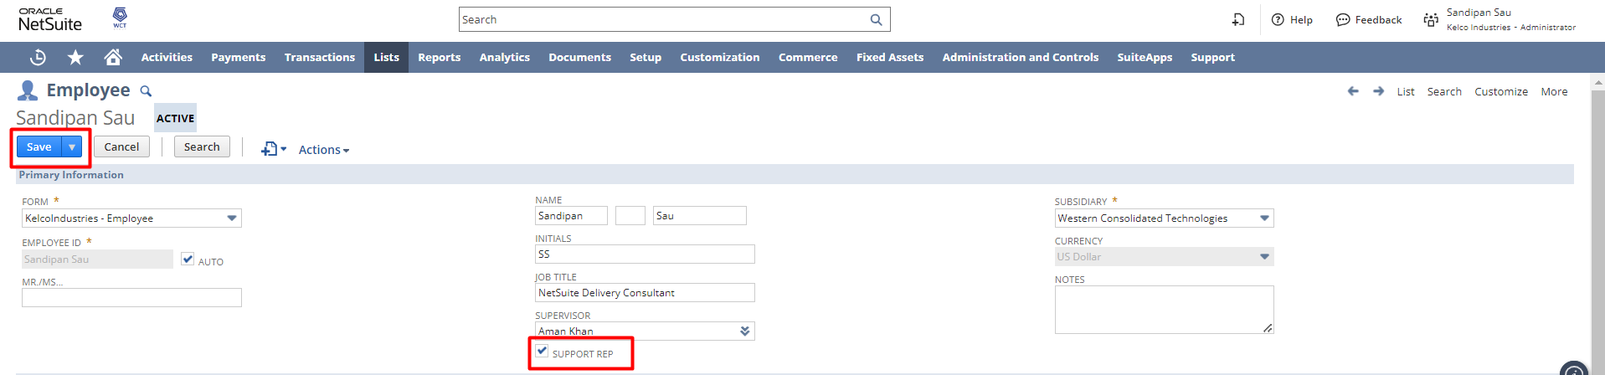
SUPPORT REP: Check this box to mark this employee as a support representative. Support representatives are listed in the assigned dropdown list for case forms and in the support rep dropdown list for support territory assignments.
- Save the Employee Record.

STEP 2: OFFER SUPPORT FOR A PARTICULAR ITEM
NAVIGATION: Lists Accounting Items
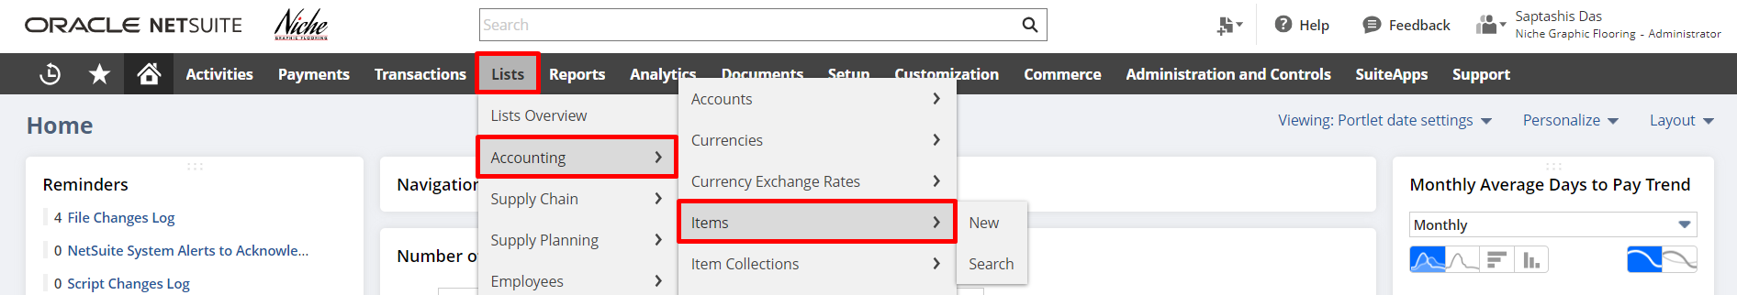
- Open an Item in Edit mode
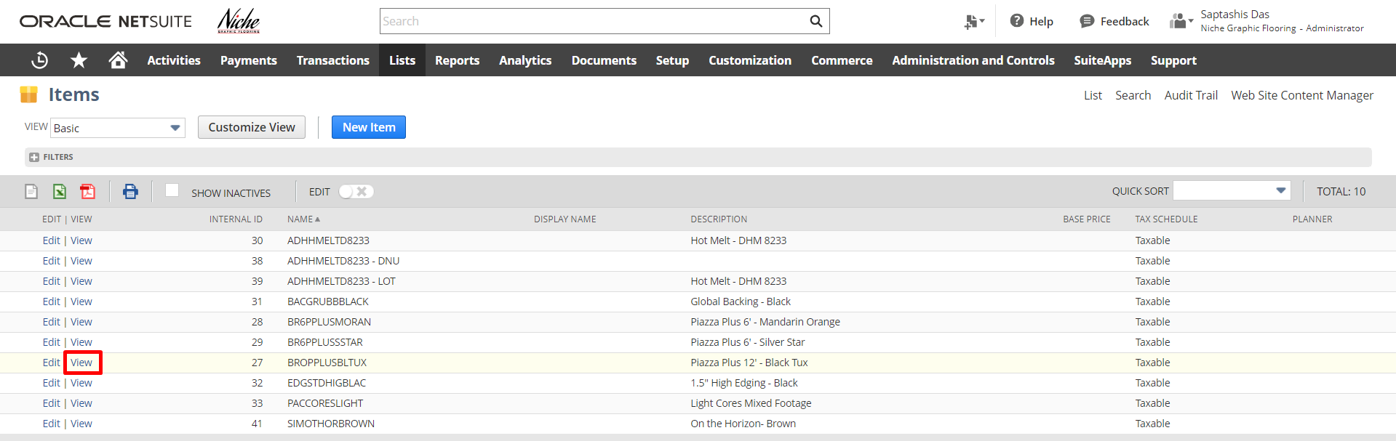
- Click on the Preferences Subtab and Check the Offer Support checkbox then Save the record. Checking the checkbox makes this item eligible for post-sales support.
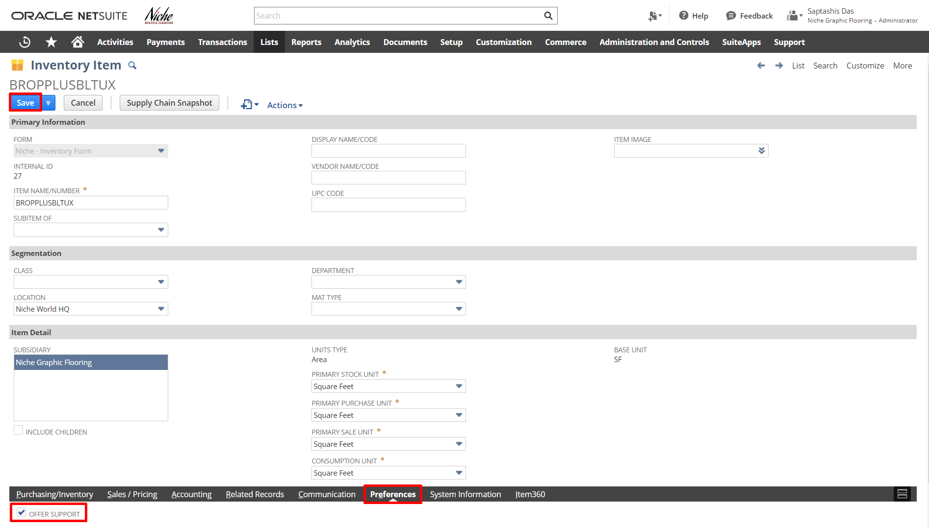
OFFER SUPPORT: Check this box to offer support for this particular item. By offering support for items, customers can select on case records which item they are having trouble with.
- Click Save

Login To Role: Customer Service
STEP 3: CREATE A NEW CASE STATUS
The following case statuses are provided by default, and can be edited:
- Not Started
- In Progress
- Escalated
- Re-Opened
- Closed
NAVIGATION: Setup Support Case Statuses New
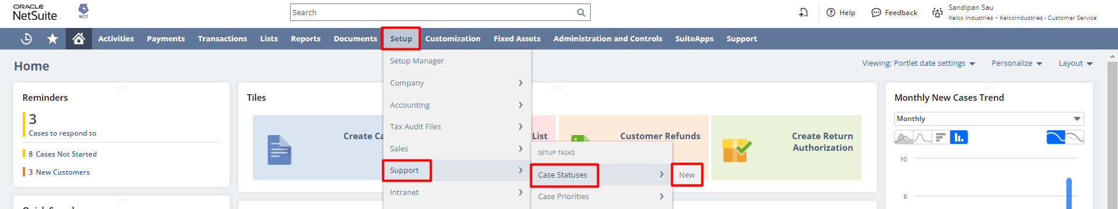

To create a case status:
- In the Case Status field, enter a name for the new status.
This name appears in the Status field on case records.
- In the Insert Before field, select where you would like this status listed in the Status field on case records.
For example, you may want to arrange statuses in order of how cases are resolved or alphabetically.
- In the Stage field, choose whether this status describes cases that are Open, Escalated or Closed.
Statuses must be associated with a stage.
For example, you can create an Awaiting Customer Response status for the Open State. This status would denote that support has asked for more information from the customer to resolve the case.
- Check the On Hold box if cases with this status should not have time counted against them.
For example, you are waiting for a reply from a customer or are waiting for a solution from another department. You can use an on-hold status to pause the case's time log. This lets you more accurately track the efficiency of a support team.
- Check the Show Awaiting Support Reply box if you want this case status to be included in searches and case tracking reports.
- If you use the Issue Management feature, check the Auto Close With Issues box. This option automatically closes a case of this status when all attached issues are closed.
You must also have the Automatically Close With Linked Issues box checked at Setup > Issues > Preferences > Issue Preferences (Administrator).
- In the Description field, enter a definition of cases that should be assigned this status.
- Click Save.

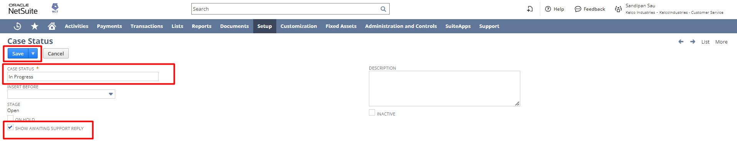

STEP 4: CREATE A NEW CASE PRIORITY
You can create new case priorities to fit the needs of your support team's case workflow. This lets you customize the rankings you give to cases to convey which cases need to be answered first.

NAVIGATION: Setup Support Case Priorities New
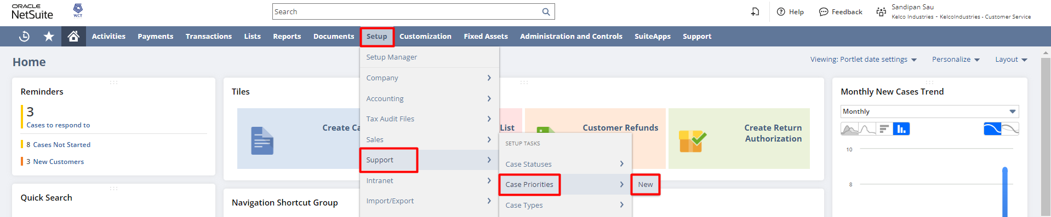

To create a case priority:
- In the Case Priority field, enter a name for the new priority.
This name appears in the Priority field on case records.
- In the Insert Before field, select where you would like this priority listed in the Priority field on case records.
For example, you may want to arrange statuses in order of descending priority or alphabetically.
- Enter a description for cases that should be assigned this priority.
- Click Save.
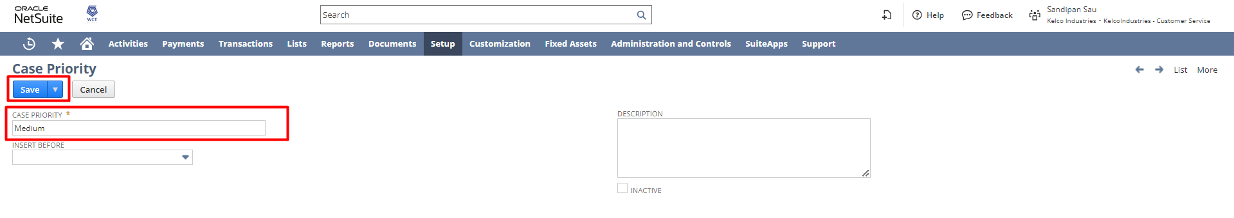
You can now select this priority on case records.

STEP 5: CREATE A NEW CASE TYPE
The Case Type field appears on case records. This field can also appear in the online case form on your Web store or Web site.
Three default case types are offered by NetSuite:
- Concern
- Problem
- Question

NAVIGATION: Setup Support Case Types New
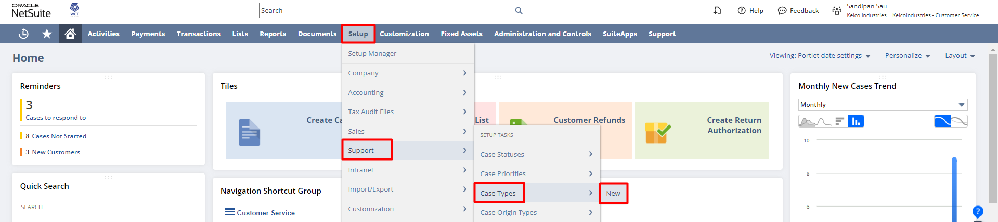

To create a case type:
- In the Case Type field, enter a name for this case type.
Customers and support reps select a case type when entering case records.
- In the Insert Before field, you can control where the new type appears in the type list in dropdown fields.
- In the Description field, enter a brief description of what cases should fit in this case type.
This description is displayed in the Support Case Types list.
- Click Save.
Your support case type is now available on case records.
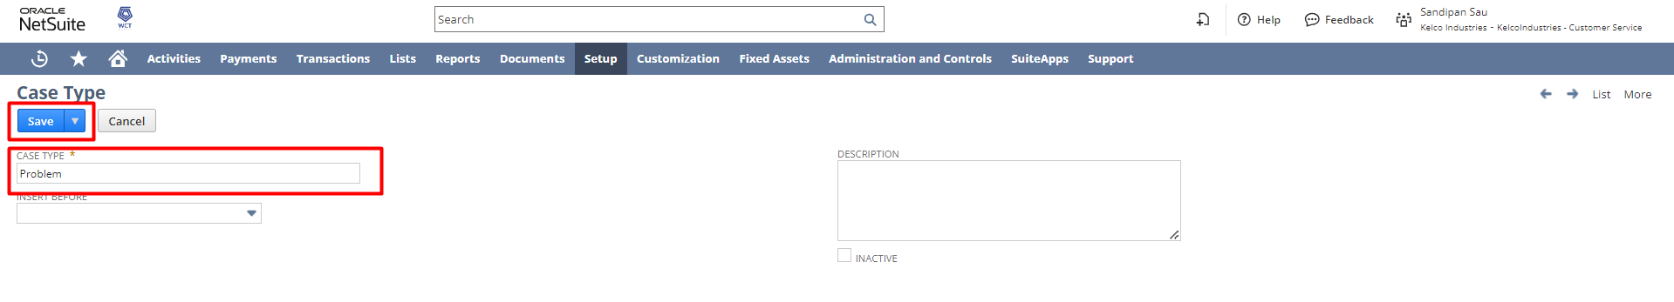

STEP 6: Support Preferences
To review and update default Support Preferences, navigate to Setup->Support->Support Preferences.
Review and make changes for each preference based on your requirements. For detailed information regarding a preference, review the field-level help for the preference.
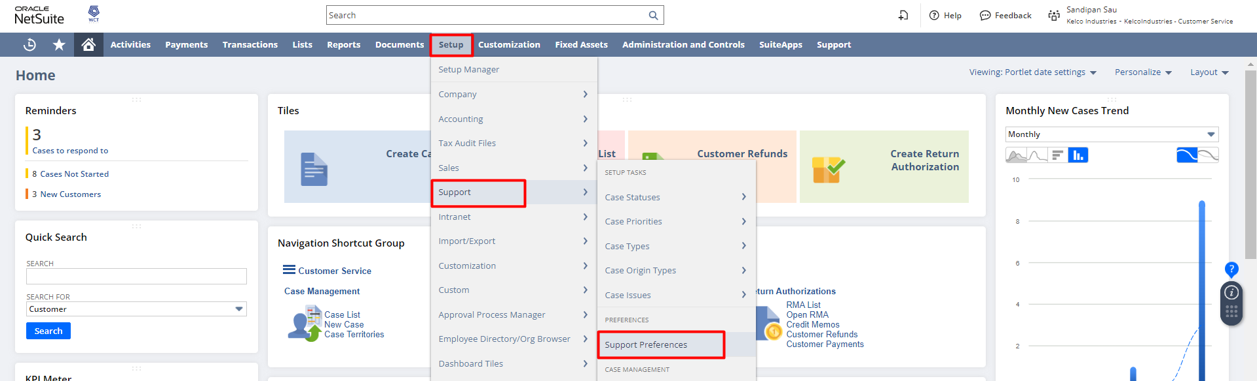
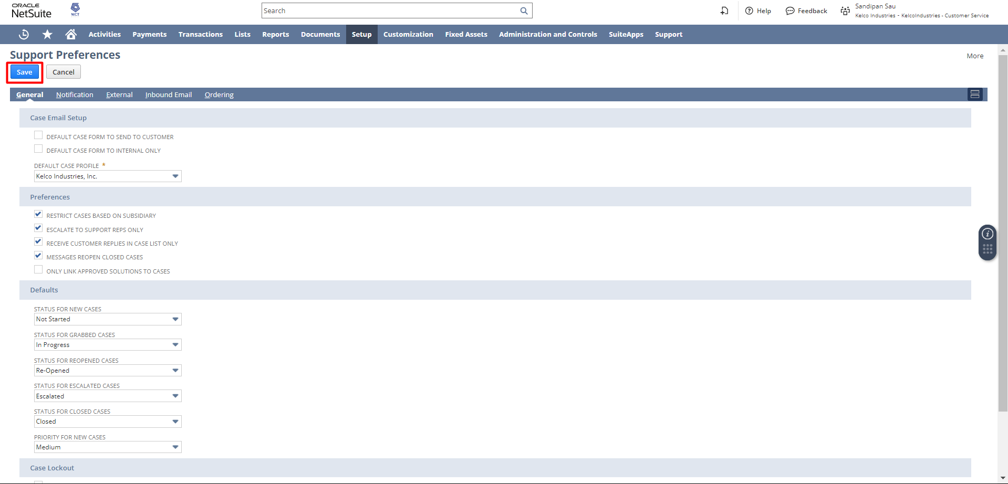

STEP 7: Create a New Case using Online Case Forms:
You can also create a case in NetSuite using Online Case Forms. You get a publishable URL that you can host on your website. When a customer clicks on the link a form like the one shown below opens. Once the customer fills the form and clicks the Submit form button a Case gets created in NetSuite. The fields in the form can be customized as per convenience.
Navigate to Setup -> Support -> Online Case Forms
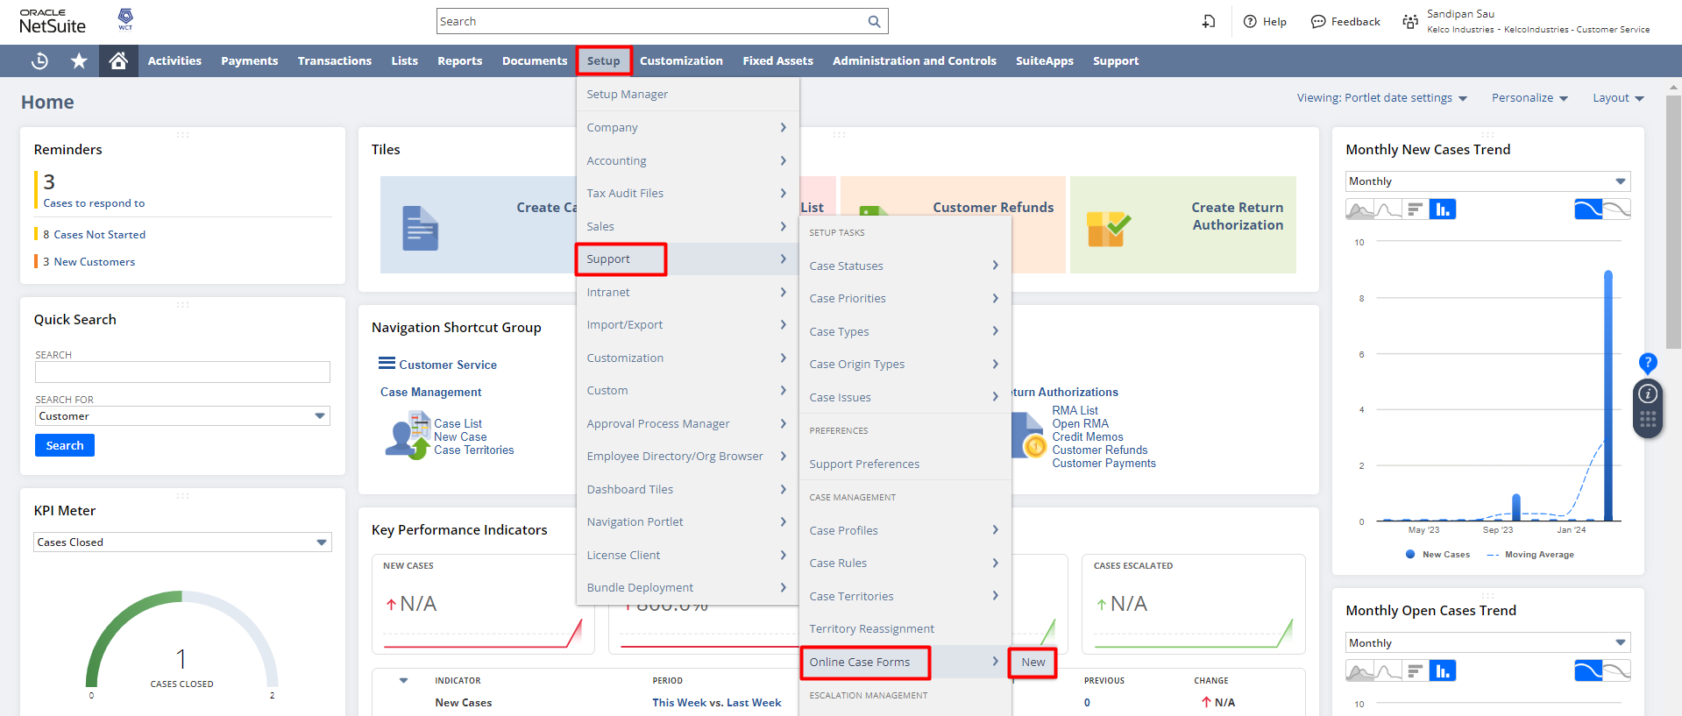
Click New Online Case Form. Select the Type of Case Form. (e.g. Default Form Template)
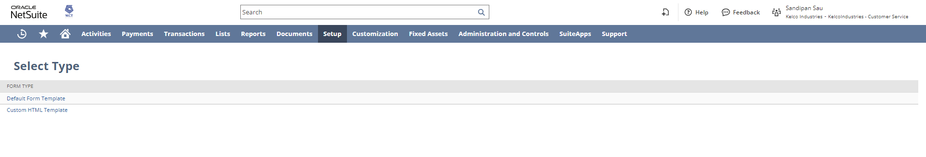
Enter the Title and required field that is required on the Case Form.
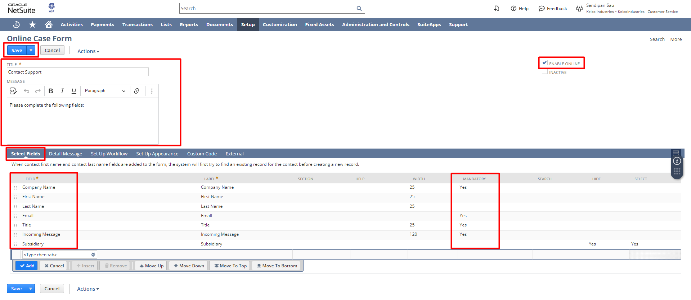
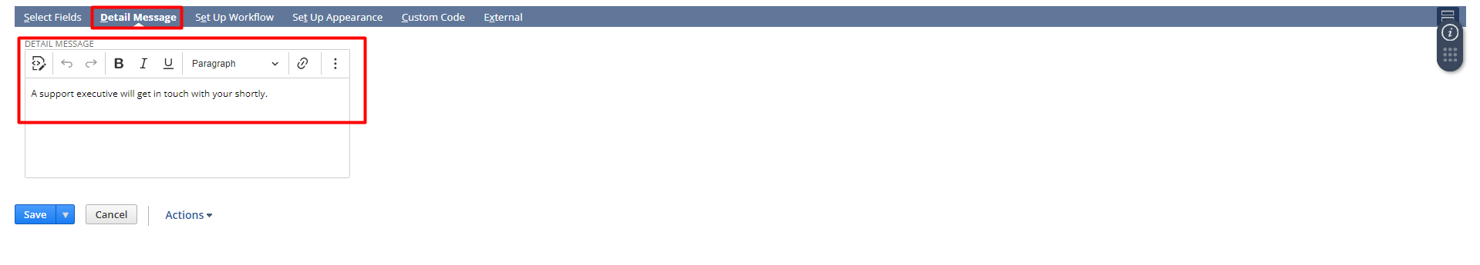
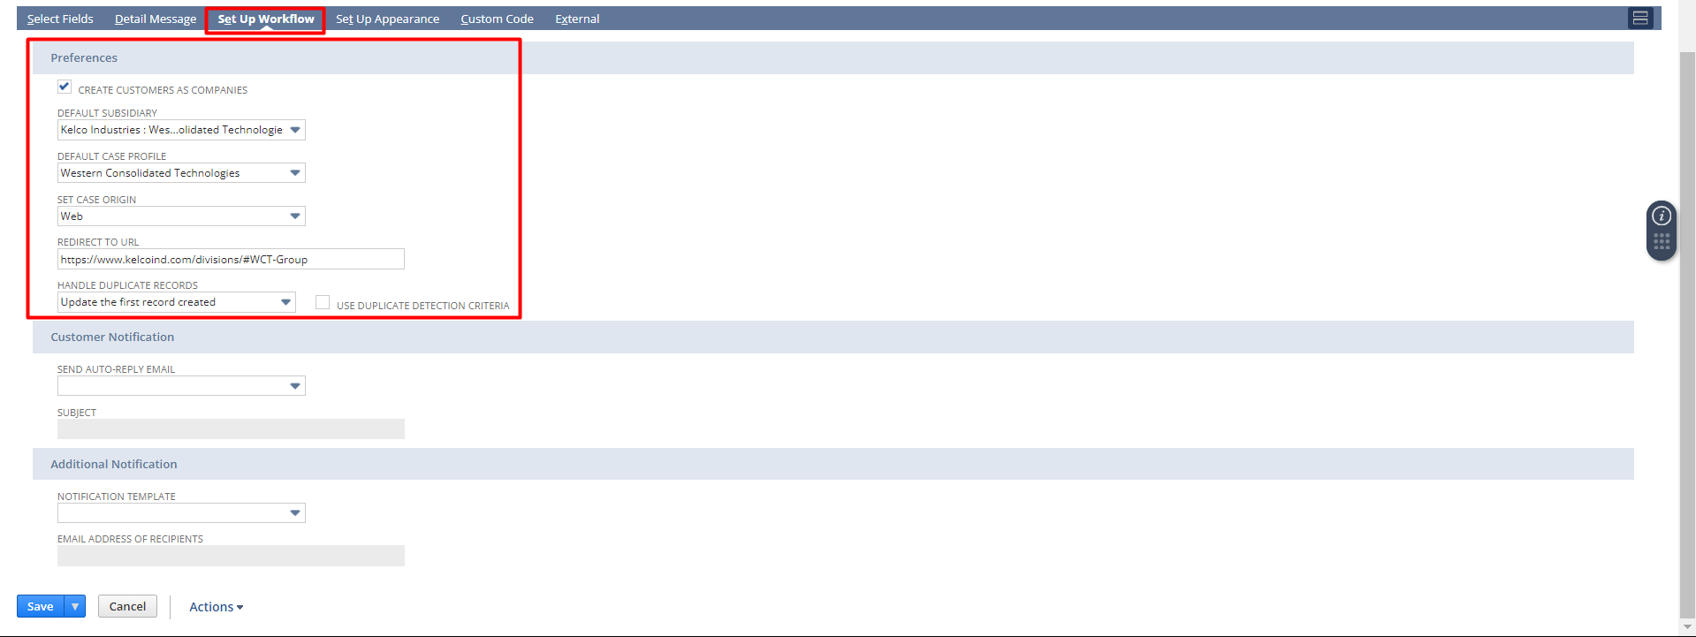
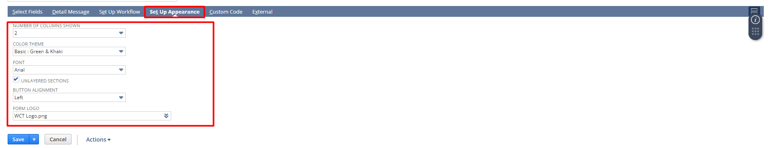
Click on Save.
Once saved Go to External subtab and click on the Publishable form URL.
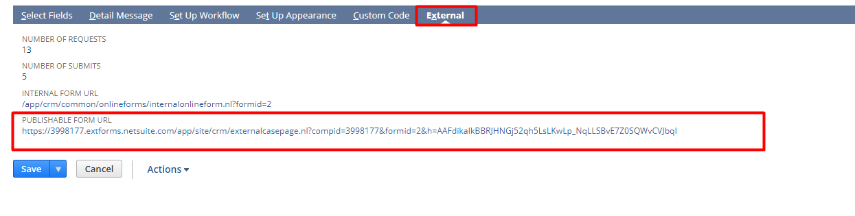
Below is the Online Case Form:
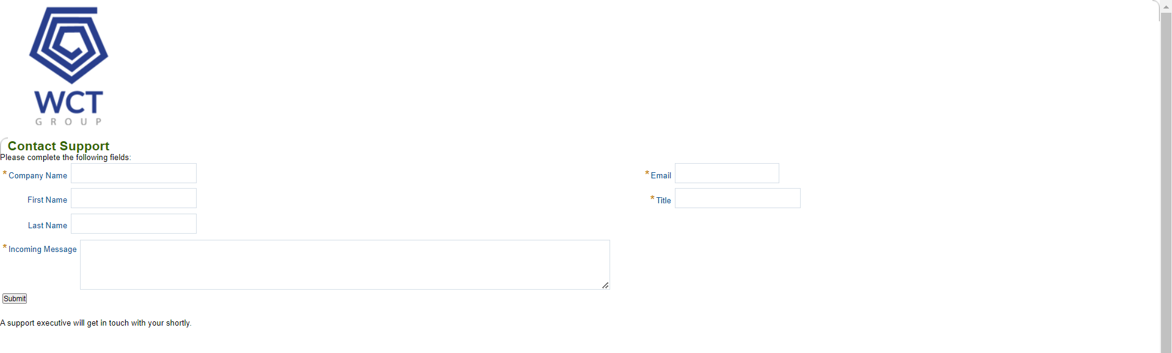

Escalation of Case
From the Status dropdown field select Escalated as the status.
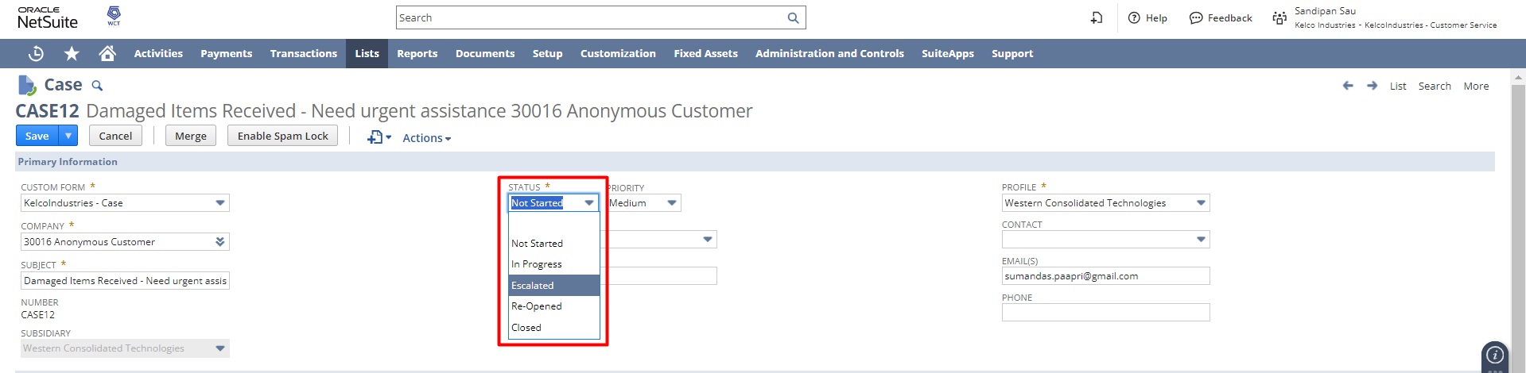
Scroll down to the Escalate subtab. Add an escalation message if any in the Escalation Message field. From the Escalate dropdown select the support rep to whom you want to escalate this case. Click the Add button. Click the Save button.
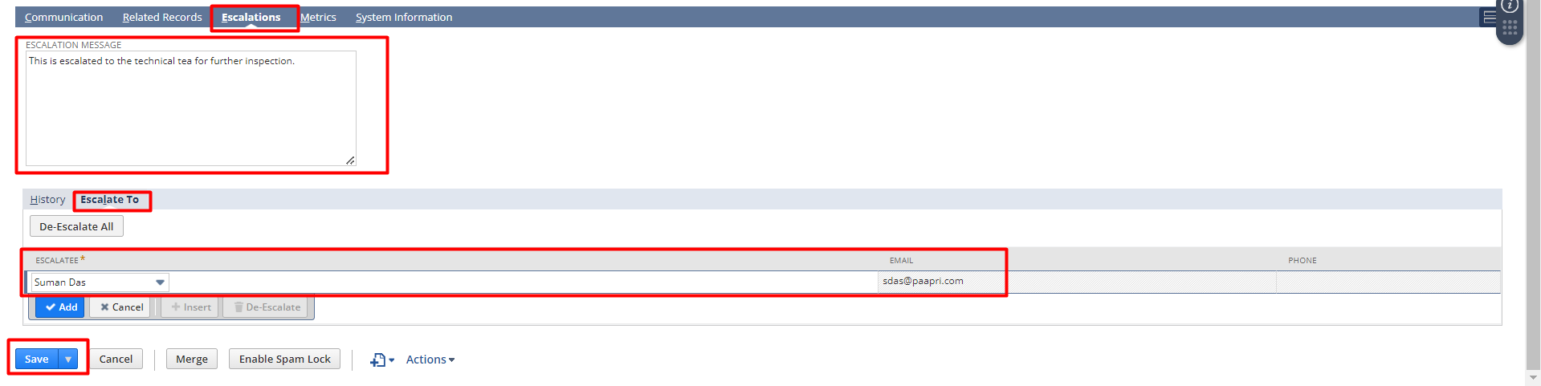

Replacement or Return against the Case

Click the Search Transaction button on an existing case.
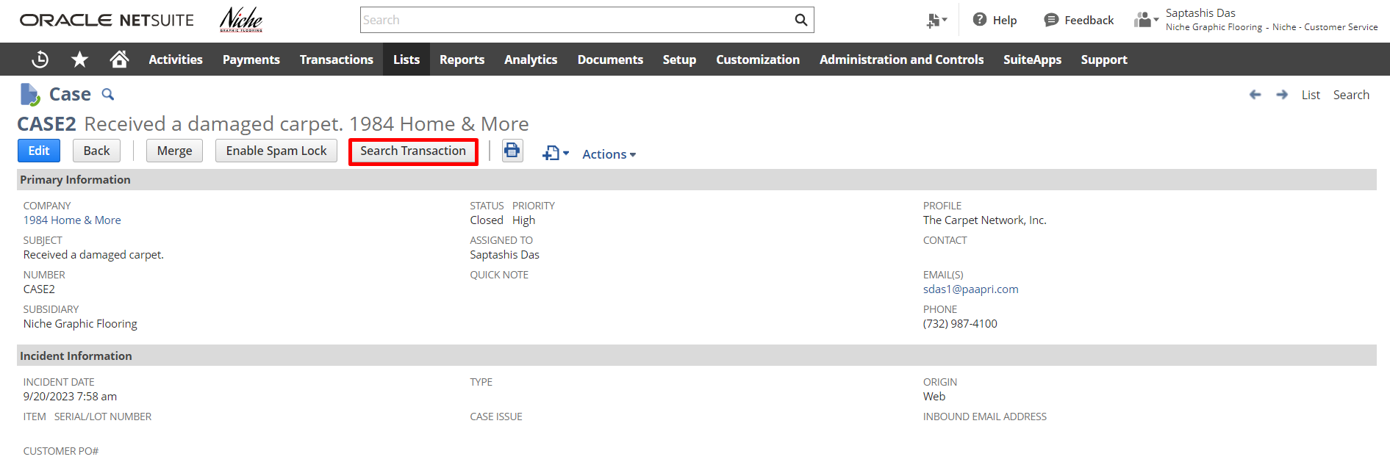
Select the transaction type as Sales Order/ Customer Invoice and click the Search button. Then Select any Customer Sales Order/Invoice Transaction from the transaction List.
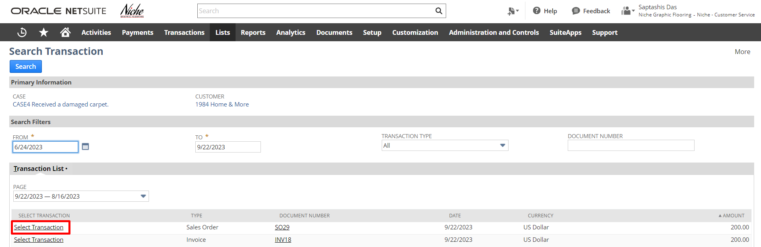
Select the item and change the quantity as per requirement. Click on the Submit Button.
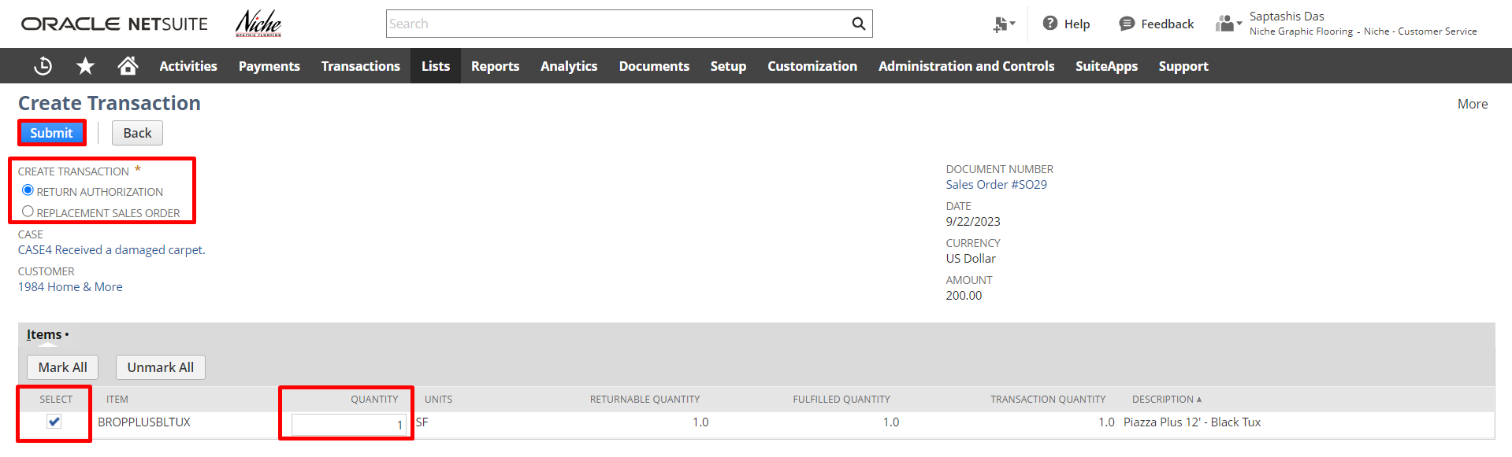
If the user selects the Return Authorization and clicks on the submit button then it will create a Return Authorization whereas if the user selects the Replacement Sales order, then it will create a Sales Order against the item that has been selected.
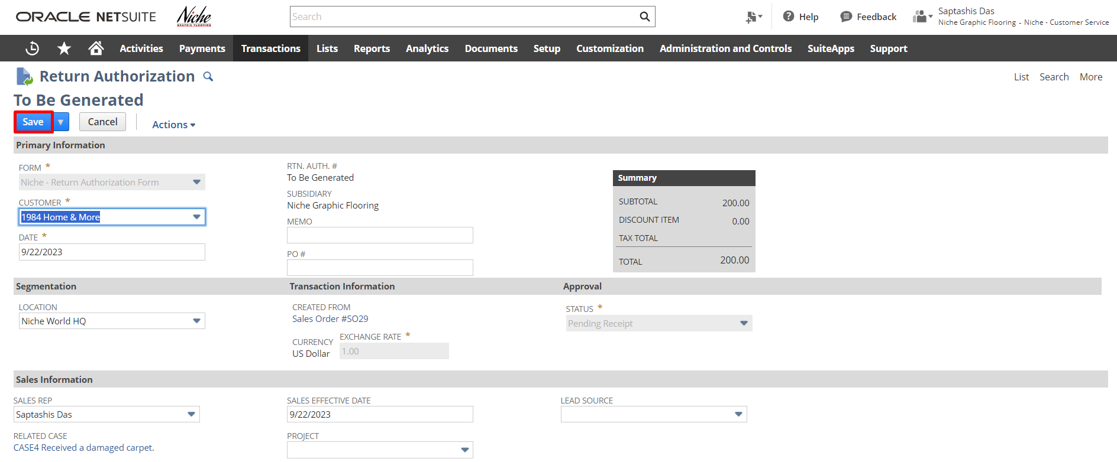
Step 5. Review the Return Authorization, make changes (if required), and Click Save.

Other ways to create a case:

By Email Forwarding:
A customer sends an email to your support address. Cases track issues your customers report and the responses your support representatives give. Cases are created when your customers report problems, ask questions, or otherwise need to communicate with you. The support email for your account is available under Support Preferences.

NAVIGATION: Setup -> Support -> Support Preferences -> Inbound email subtab


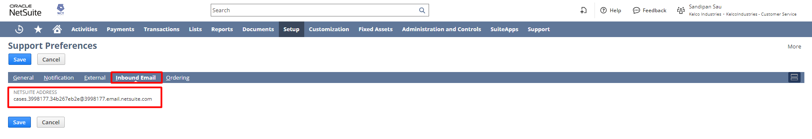

By Case Forms:

A support rep should use the following steps to create a case record when a customer calls in.

Lists Support Cases New
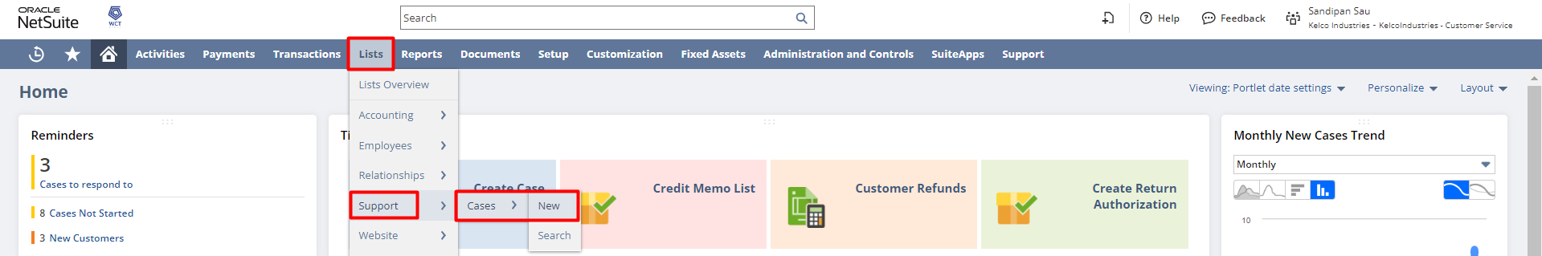
To enter a case:
- Under Primary Information:
  - Select the form you want to use to enter this case in the Custom Form field.
You create custom case forms at Customization > Forms > Entry Forms.
  - Enter the subject of this case.
  - Select the company this case pertains to.
Companies and individuals, you have customer or partner records for appear in this list.
  - Select the profile you want to assign to this case. This profile determines the from name and from email address shown on email notification sent for this case and the notification templates used.
  - Select the person or group this case is assigned to.
  - Select the contact who is reporting this support issue.
  - Enter the email address(es) of the customer or contact.
You can enter multiple email addresses separated by commas or semicolons.
When you check the Email Reply box under your message, the message is sent to all addresses in this field.
  - In the Phone field, enter the customer or contact's phone number.
  - Select the status of the case.
The status of a case can help you track the case workflow process and report progress. You can also place a case on hold using case statuses.
  - Select the priority of the case.
Case priorities can help determine how important it is to answer a case quickly.
  - In the Quick Note field, add a short note about the case.
This note can only be seen internally by those in your support team with access to the case. You can also add this field to the cases list to allow you to make notes when viewing the list.
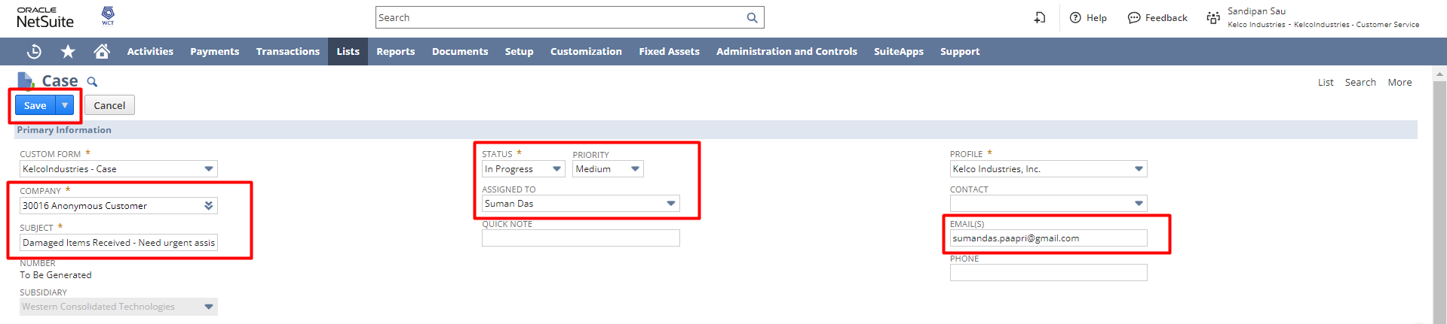
- Under Incident Information:
  - In the Incident Date field, enter or pick the date of the issue or problem or when the issue was reported.
  - In the Incident Time field, enter the time the issue or problem occurred or was reported.
  - If you offer support for items, select which item this case refers to.
To offer support for an item, go to the item's record, and check the Offer Support box.
  - If you use serial numbers, you can select the serial number for the item in the Serial/Lot Number field.
  - If you use the Issue Management feature, select a product this case pertains to.
  - If this case pertains to a product, select the appropriate module for that product.
  - Select what type of issue this is.
Administrators and Support Administrators can create new case types at Setup > Support > Setup Tasks > Case Types > New.
  - If you offer support for issues, select which issue this case is for.
Administrators and Support Administrators can create support issues at Setup > Support > Setup Tasks > Case Issues > New.
  - In the Origin field, select how this case was reported.
  - If you use the Help Desk feature, check the Help Desk box if this is an internal case entered by an employee.
- Click the Communication subtab.
  - In the Message field, enter the message that the customer sent you.
  - If you would like to add a solution to the reply, do one of the following:
Solutions are attached at the end of the reply. If you are emailing a reply to the customer, the text of the solution is included at the end of your reply.
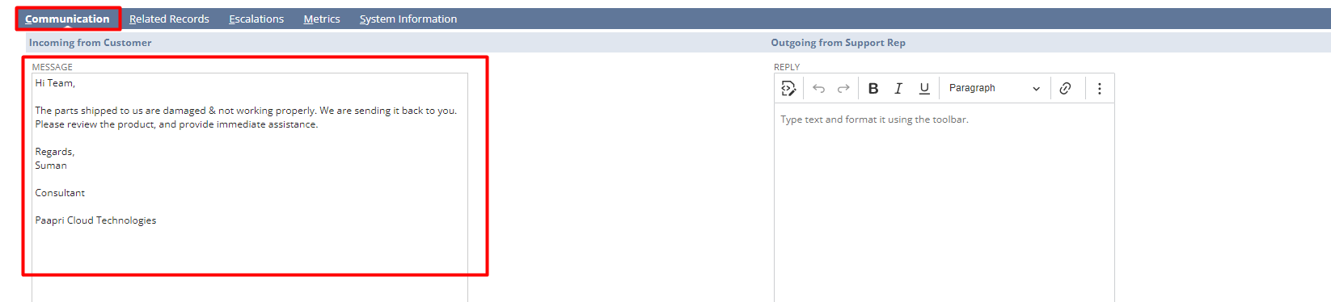
This reply is recorded on both the customer and case records.
- Check the Internal Only box if the reply should be sent only to the employees selected in the Copy Employees field.
  - Click the following links to view information for other subtabs:
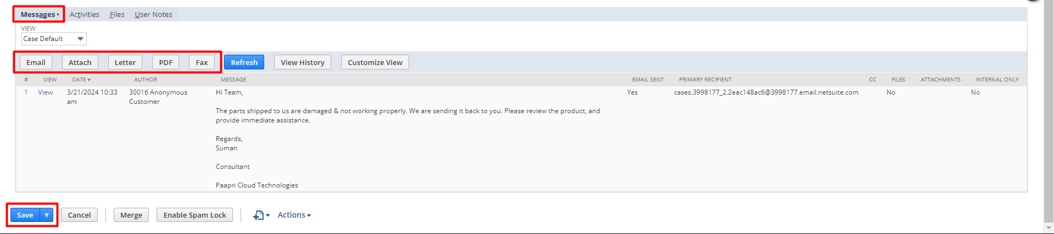
- Click Save
This case is now saved as an open case in the cases list with a response status of Awaiting Support Reply. When you answer the case, whether you close the case or not, the response status is set to Awaiting Customer Reply.
Customer issues, questions, or other feedback entered through an online case form or email to your support address automatically creates a case record. NetSuite creates the case record with the information the customer submits and sets the status to Awaiting Support Reply.

Please utilize the below feedback link for the Case to Resolution module:
https://form.typeform.com/to/woCmtXub

Signature: ________________________________
Date: _____________________________________

Disclaimer:
Upon signing off on the process flow document, you are confirming that the process has been set up per the SOW within NetSuite per your business's needs. Any changes or modifications requested after sign-off will need to be a "change request" at an additional fee.

*** PLEASE ensure that you have logged into NetSuite and tested the process prior to signing off on the setup. Paapri requires sign-off on this document prior to moving forward with any additional design meetings.

